<http://mnras.oxfordjournals.org/content/410/1/166.full.pdf>

* Images from Sloan Digital Sky Survey
  + ~26% of the sky
  + 5 filter photometry
* 738,175 galaxies and 155,037 other objects included in SDSS
* Images from ImgCutout web service from SDSS SkyServer site (Data Release 6)
* clean/superclean samples defined by percentage of users to classify galaxies a certain way → percentage threshold varies by feature
  + Uncertain classification given to galaxies which do not meet the “clean” criteria
* Biases can be shown in studies where galaxies were presented either mirrored or in grayscale– users were more likely to classify grayscale images as elliptical; bias for anticlockwise spiral classification was found.
* Bias correction formulas were developed based on observations of galaxies from nearby systems. In released data tables, data is provided both with and without bias correction for classification as elliptical and combined spiral galaxies.
* “Clean” sample where 80% of the **corrected** vote classifies a galaxy in a particular way
  + 50% → greater
  + 60% → cleanish
  + 80% → clean
  + 95% → superclean
* Graphs below display how frequently galaxies are estimated to remain misclassified or unclassified using differently stringent classification thresholds. 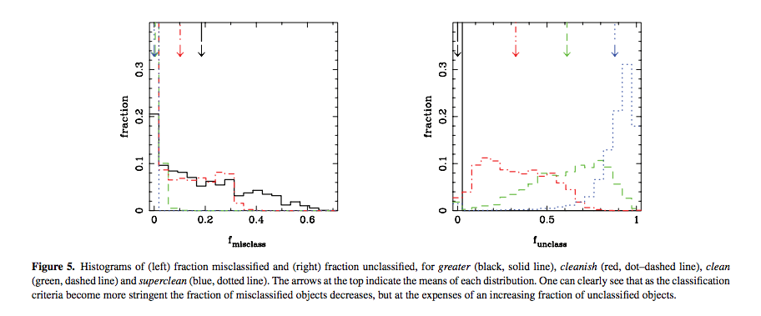
* Data released for 667,944 galaxies
* **67,658 spiral galaxies where 20% or less of people classified them as edge-on**

Explore SDSS skyserver: <http://skyserver.sdss.org/dr13/en/tools/chart/navi.aspx>

Search by OBJid: http://skyserver.sdss.org/dr7/en/tools/explore/obj.asp?id=[insert id number]

→ when retrieving images: either zoom in, increase photo size in px, or both – otherwise image will be too blurry to use

OKAY HERE WE GO:

[http://skyservice.pha.jhu.edu/DR7/ImgCutout/getjpeg.aspx?**ra=0.16125**&**dec=14.59672**&**scale=0.09903**&width=**512**&height=**512**&opt=&query=](http://skyservice.pha.jhu.edu/DR7/ImgCutout/getjpeg.aspx?ra=0.16125&dec=14.59672&scale=0.09903&width=512&height=512&opt=&query=)

**Scale measurement refers to the scale of the image in degrees per pixel.**

**Width and height designate the size of the image in pixels.**

## *rara must be in [0,360], dec must be in [-90,90], scale must be in [0.015, 60.0], height and width must be in [64,2048]*

<http://www.sdss.org/dr13/imaging/imaging_basics/>

SDSS scans with a *ugriz* filter set: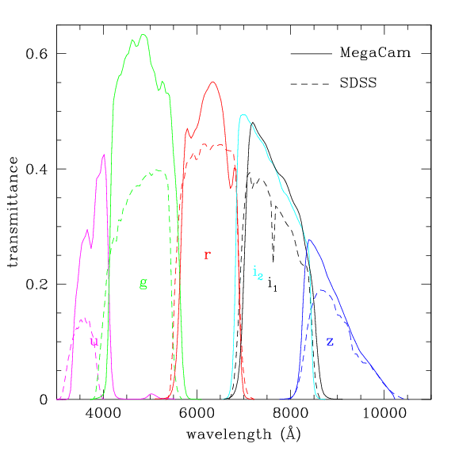

*Source:* <http://www.cadc-ccda.hia-iha.nrc-cnrc.gc.ca/en/megapipe/docs/filt.htmlhttp://www.cadc-ccda.hia-iha.nrc-cnrc.gc.ca/en/megapipe/docs/filt.html>

Where 80% is our “clean” mark:

Data released for 667,944 galaxies

↓

190,227 flagged as spiral

↓

67,658 spiral galaxies where 20% or less of people classified them as edge-on

↓

14,776 cleanly classified as clockwise and 15,944 cleanly classified as anticlockwise

**31,439 galaxies can be cleanly classified as non-edge-on spirals with discernable direction.**

[**https://docs.python.org/2/howto/urllib2.html**](https://docs.python.org/2/howto/urllib2.html)

[**http://docs.python-guide.org/en/latest/scenarios/scrape/**](http://docs.python-guide.org/en/latest/scenarios/scrape/)

**/html/body/p[1]/table/tbody/tr[2]/td[1]/a/img**

**body > p:nth-child(1) > table > tbody > tr:nth-child(2) > td:nth-child(1) > a > img**

